Project Development Phase
Model Performance Test

Date | 03 October 2026
Team ID | Team 12
Project Name | Streamlining IT Procurement: Automating Standard Laptop Orders with Flow Designer
Maximum Marks | 10 Marks

Model Performance Testing:
Project team shall fill the following information in model performance testing template.
S.No. | Parameter | Values | Screenshot
 | Metrics | Workflow Execution: Successful  Request Processing: Successful  Approval Processing: Successful  Inventory Check: Successful  Procurement Request: Successful  Notification: Successful | 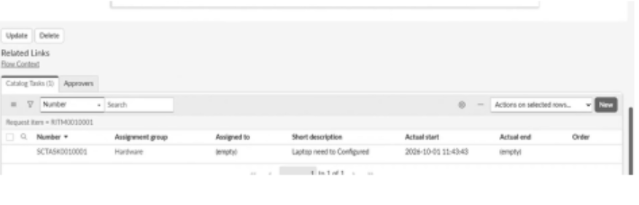
 | Tune the Model | Workflow Configuration: Configured according to the laptop procurement process  Validation Method: Functional and end-to-end testing using different request scenarios | 